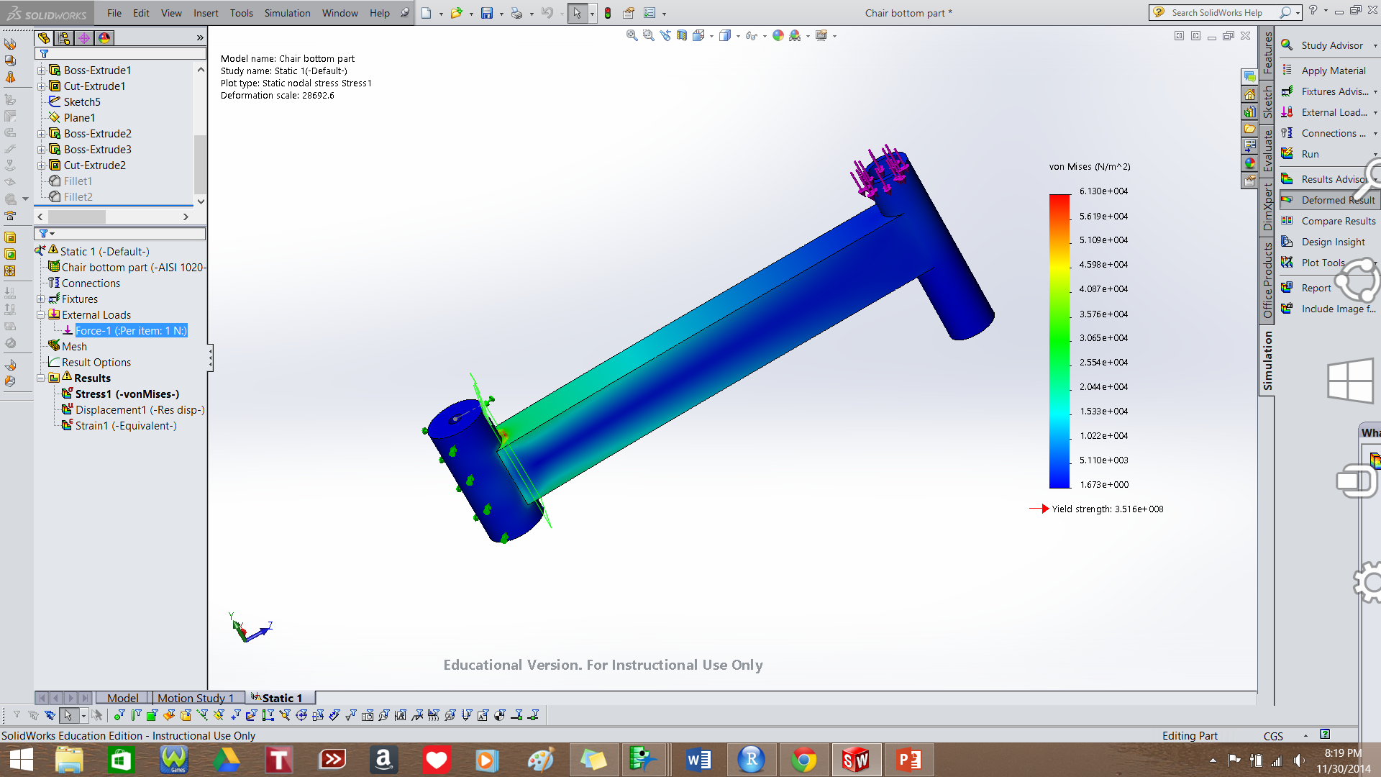

Max stress: 6.130e4 Pa

Location: shown in red

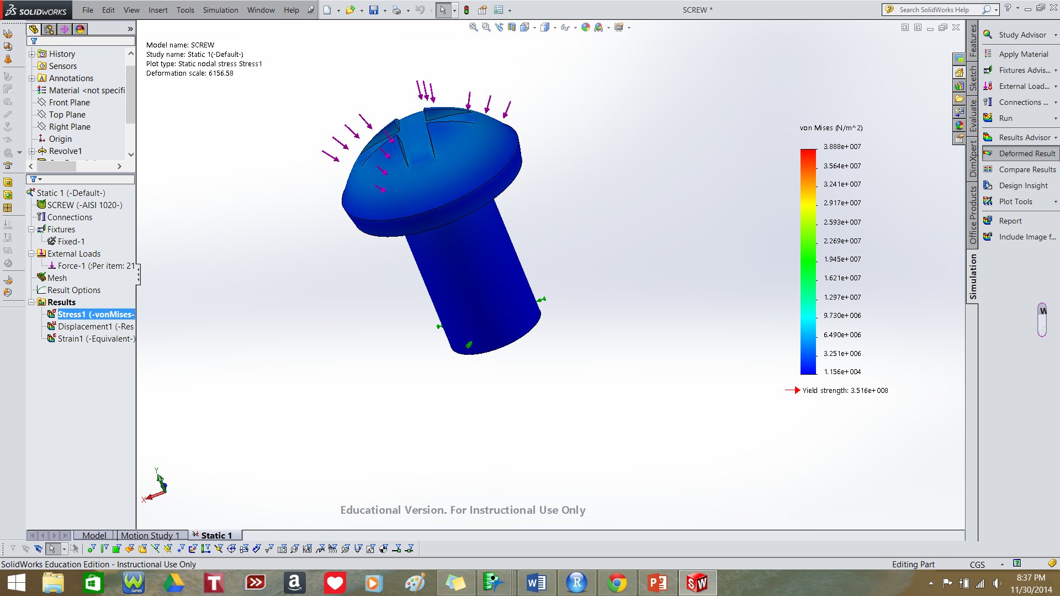

Max stress = 3.888e7 Pa (38.88 MPa)

Location: along edge where cylinder and bolt top are joined (can’t see in picture)

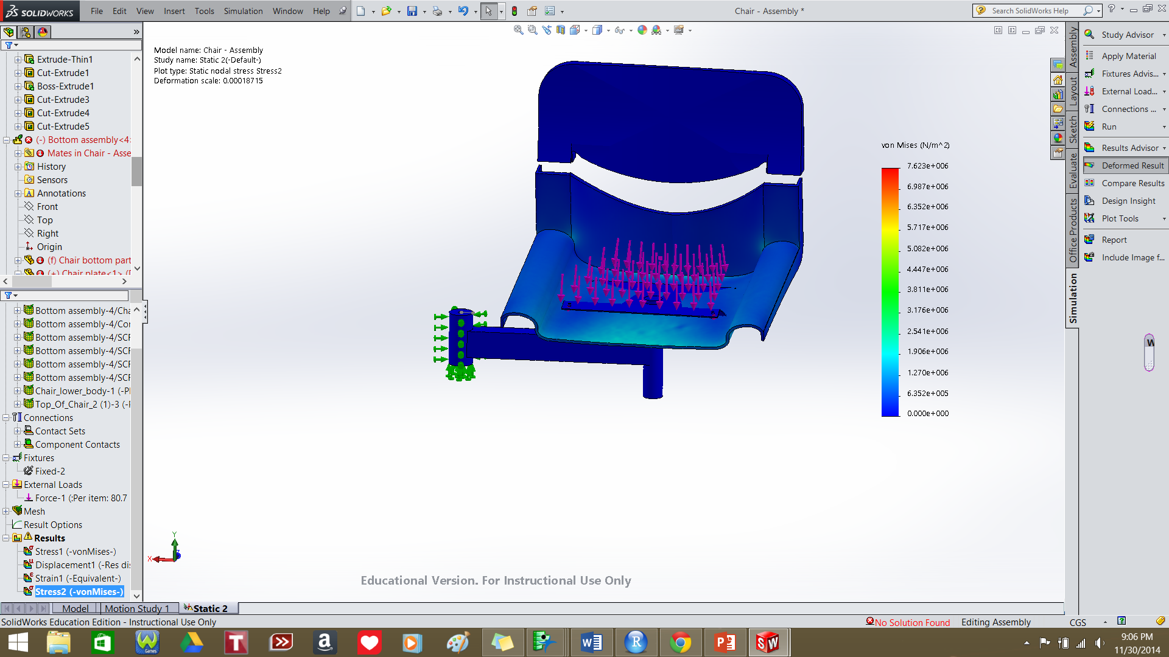

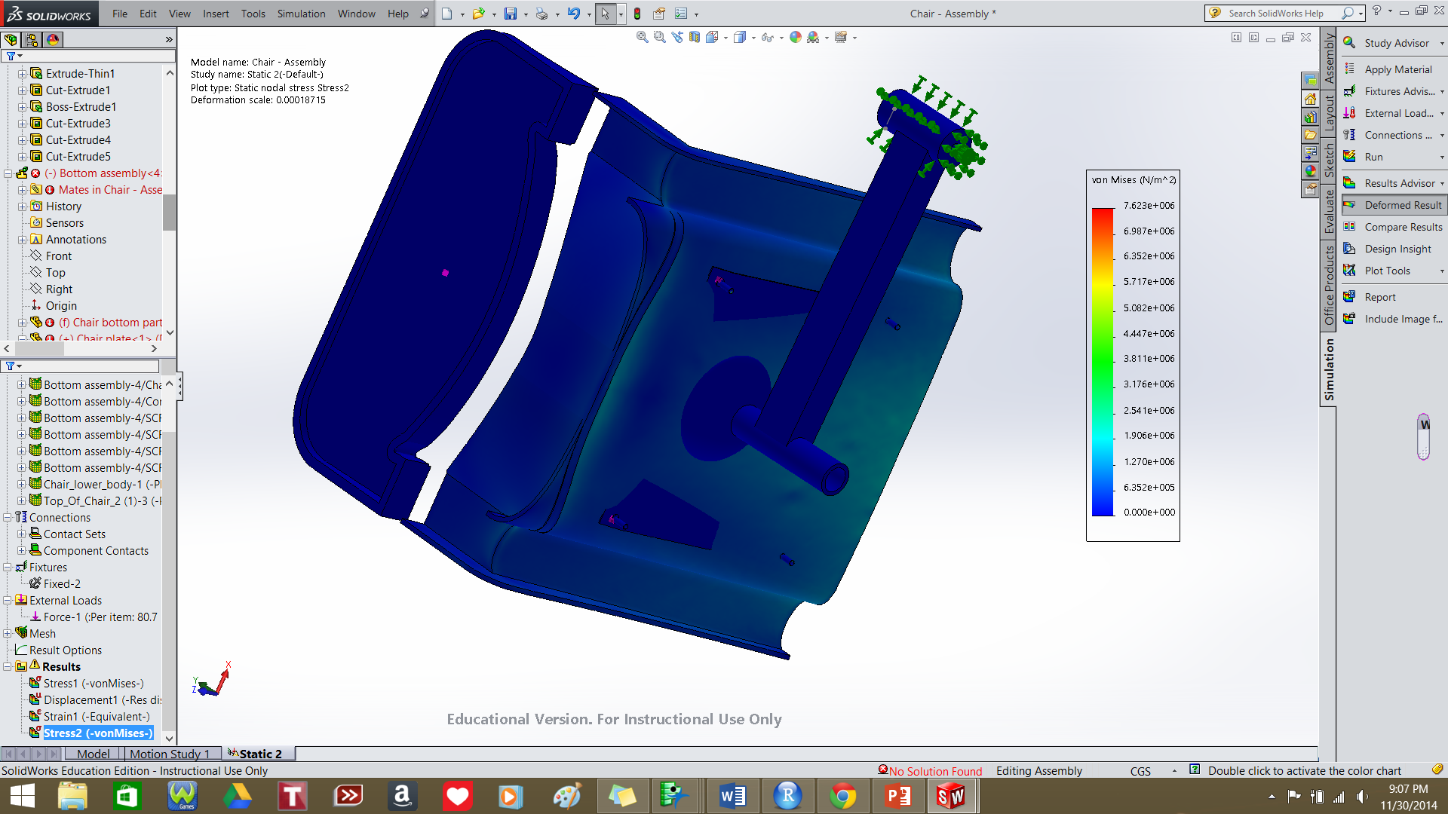

Max stress = 7.623e+006 Pa = 7.62 MPa

Locations: Cylindrical shells for connecting screws